CHAPTER-1
INTRODUCTION
Social networking service has become a powerful tool for expressing people’s views with other users around the world and also to build social relations with other people who share similar personal or career interests, activities, backgrounds or real-life connections. Social networks like Twitter, Facebook, etc have become marketing and communication tools and have gained much popularity in last few years. These sites involve a large amount of subjective information, [9] opinions on different aspects of their everyday life which includes reviews, emotions and feelings.
1.1 OVERVIEW OF TWITTER
Twitter has recently evolved as popular micro blogging site [5]. It is an online news and social networking service where users post and interact with messages, known as "tweets." The short nature of updates allows users to post news items quickly, reaching audience in seconds. These messages limit is up to 280 characters. Twitter is not just for tweeting about their daily activities but also a medium for real-time information dissemination and it has been used in various brand campaigns, elections, and as a news media.
Twitter's real-time functionality is as an effective communication system for breaking news. Twitter has acted as a sensor for automatic response to natural disasters such as bush fires.
Twitter has been adopted as a communication and learning tool in educational and research settings mostly in colleges and universities. It has been used as a backchannel to promote student interactions, especially in large-lecture courses.
As Twitter is very much popular site in all around the globe, huge amount of population in the world uses Twitter and generate millions of tweets each day. In order to gain opinion of speaker behind certain topics sentiment analysis is been done. The attitude of speaker may be his or her judgment or evaluation, affective state (the emotional state of the author while writing), or the intended emotional communication (the emotional effect the author wishes to have on the reader). This analysis mainly classifies “tweets” into positive, negative and neutral sentiment[19] [2].
It is very interesting to know what topics are trending and what people in other parts of the world are interested in. A very high percentage of trending topics are hashtags, a name of an individual, or words in other languages . It is often difficult to understand what the trending topics are about. If a user wants to search tweets about a particular topic then the categorization of tweets must be done.
1.2 MOTIVATION
Twitter streams are un-categorized and noisy data. Categorization of tweets can help organize a user's incoming Twitter feed. This will increase readability and filter out unwanted categories at times and helps in better information retrieval. Tweet classification is widely used in product reviews, video reviews, and social public opinion analysis and micro-blogging attitude.
When categorization of tweet is applied following problems arises: Named Entity Recognition(NER): NER is method of extracting entities such as people, location from Twitter, Parsing: It is to identify the subject of tweet ,Sarcasm: Contrast between a Positive Sentiment and Negative Situation, Sparsity: Insufficient data in training set, Twitter abbreviations, Poor spelling and poor grammar, Incomplete sentences.
In order to address the above problems and to get useful and meaningful data from the vast amounts of tweets in Twitter, tweets needs to be preprocessed and then tweets need to be categorized into general classes like: arts & design, books, business, charity & deals, fashion, food & drink, health, holidays & dates, music, politics, religion, science, sports, technology, TV & movies, other news and others for easier understanding of topics.
Manually categorization of tweets is not practical when dealing with a large amount of data so some automatic method has to be found. To classify trending topics into these predefined classes, common approaches are Bag-of-Words technique, social network information, and network-based classification. Bag-of-words technique [7] had a drawback that all the words in training set had to be included in the testing set. Various machine learning algorithms like Naive Bayes, SVM, random forest and Maximum Entropy are also used for categorization of tweets.
1.3 OBJECTIVE
This project mainly focuses on Classification of tweets into particular category by improving the performance metrics of various machine learning algorithms like Naïve Bayes, SVM, ensemble classifiers and using liblinear. A comparison between machine learning algorithms and ensemble classifier is also performed.

1.4 ORGANIZATION OF REPORT
The detailed organization of report is as follows
Chapter 2 deals with the literature survey.
Chapter 3 deals with the system design of the developed system
Chapter 4 deals with implementation of the developed system
Chapter 5 deals with various results that have been obtained
Chapter 6 deals with conclusion and future work

CHAPTER 2
LITERATURE SURVEY
This chapter deals with various studies and results that have been published in past relevant to classification of tweets, sentiment classification and opinion mining.
2.1 SENTIMENT ANALYSIS
Sentiment analysis is performed to determine the tone of tweet. Main objective in the research of Wilson [16] was to develop a new approach for the tweet sentiment analysis. They used phrase-level sentiment analysis that first determines whether an expression is neutral or polar and then disambiguates the polarity of the polar expressions. With this approach, the system is able to automatically identify the contextual polarity for a large subset of sentiment expressions, achieving results that are significantly better. Tapan [14] used distance supervision for twitter sentiment analysis but this approach requires huge computation resource for analyzing. So, the author proposed technique to speed up the computation process for sentiment analysis. He introduce the concept of EFWS (Effective Word Score) of tweets which is an additional heuristics used to speed up the sentiment classification with machine learning algorithm. Luo [9] highlighted an efficient technique to mine opinions from twitter tweets. Spam and wildly varying languages makes opinion retrieval within twitter challenging task.

2.2 SENTIMENT CLASSIFICATION
Sentiment classification and analysis is the important field in twitter data mining. In the research of Cambria [3], they used lexical-based approach for sentiment classification. The weakness of this approach is poor recognition of tweet when negation is involved. Pak and Paroubek [6] proposed an approach that retrieves tweets from twitter API and builds a sentiment classifier. The main aim was to determine positive, negative and neutral sentiments for a document and found that proposed technique produces better classification accuracy. J.Read [8] used emoticons to collect tweets with sentiments and to categorize them into positive and negative tweets.
2.3 TWEET CATEGORIZATION
Tara [4] used naïve bayes for categorization of tweets and also proposed a method that apply Map-Reduce paradigm to existing Naïve Bayes algorithm to handle large number of tweets. Stavrianou [22] used Stanford NLP techniques to classify the tweets but it fails to capture the information needed for extracting of information. A combination of NLP and Machine Learning techniques seems more promising for task. Thus they proposed method that performed automated tweet classification of political tweets using decomposition of hash tags in the process among other NLP features. Xiang [19] used word embedding based clustering method for classification. Here the tweets are represented as a vector and divided into cluster. Based on the similarity, it is classified as related or unrelated topics.

2.4 COMPARISON OF CLASSIFIERS
Dwi [7] compares classification performances of three machine learning algorithm namely SVM, Decision tree and naïve bayes and conclude that SVM approach works best. Yi [15] and Songbo Tan[18] also discovered that SVM performs better than the Naïve Bayesian approach and an N-gram model . Different from other machine learning methods, the K-nearest neighbors (KNN) method does not extract any features from the training dataset but compare the similarity of the documents with its neighbors. Ajay [10] presents an empirical comparison of six supervised classification algorithm for designing accurate and efficient sentiment classification system.
2.5 IDENTIFICATION OF EVENTS
Another area of research related to twitter data mining is event identification. Sakaki [5] proposed an algorithm to identity target events and considering tweets-related features and their context for detecting the target events. The main focus of their study is to identify earthquakes event. Cheong and Lee [21] used Self Organizing Map (SOM) related to 2009 Iran election issue and the iPhone OS 3.0 software launch for detection of interesting patterns. Chung and Mustafaraj [2] examined the predictive power of social media using sentiment analysis method and identified conflicting results in the domain of US political election held in 2010.
2.6 ENSEMBLE CLASSIFICATION
Yun [11] used ensemble sentiment classification strategy based on majority vote principle of multiple classification methods. Following algorithms were used in majority vote principle naïve bayes, SVM, Bayesian network ,decision tree and random forest algorithm.
The results show that ensemble approach improves the accuracy in twitter sentiment classification. Apart from that, Cui [1] presented an ensemble method that combines classifier outputs by including the individual probability distributions with an additional learning layer. A mapping method to employ a cloud taxonomy service is used as an additional classifier. The ensemble methods include LLDA, Naive Bayes, and the cloud taxonomy service. These methods have been applied on a real industry tweet dataset. Xia [13] also used ensemble framework for Sentiment classification but in their work they used two types of feature sets (Part-of-speech information and word relation) and three base classifier (Naïve Bayes, Maximum Entropy and Support vector machine).

CHAPTER 3
SYSTEM DESIGN
This chapter deals with overall architecture of the system and various tools and packages used for implementation
3.1 SYSTEM ARCHITECTURE
Tweets collection
Tweet preprocessing
Tweet classification
Labeled tweets

Performance analysis

Fig 3.1 (system architecture)

The architecture of the system has mainly five components as shown in figure 3.1
The system consists of the following modules
- Tweet collection
- Tweet Preprocessing
- Tweet classification
- Performance analysis of classifiers
- Result module

3.1. 1.TWEET COLLECTION
Tweet extraction is to fetch the tweets using Twitter API[6] . APIs is to access Twitter data and can be classified into two types based on their design and access method:
• REST APIs are based on the REST. These APIs use the pull strategy for data retrieval. To collect information a user must explicitly request it.
• Streaming APIs provides a continuous stream of public information from Twitter. These APIs use the push strategy for data retrieval. Once a request for information is made, the Streaming APIs provide a continuous stream of updates with no further input from the user.
In order to have access to twitter data, there is a need to create an app that interacts with the twitter API, consumer key and consumer secret key is provided by twitter which should be kept private. From the configuration page of app, access token and an access token secret will be provided, which provides the application access. Tweets were collected using various hash-tags like #movies, #books, #science, #sports, #politics, #law #environment etc. The tweets collected in a streaming fashion represents a true sample of actual tweets in terms of language use and content.

3.1.2 TWEET PREPROCESSING
In order to remove stop words and extract features we perform data cleaning and normalization. Preprocessing of data is the process of preparing and cleaning the tweets for classifying. Reducing the noise in the text helps to improve the performance and speed up the classification process [23]. This project performed the following operations on tweets during cleaning and normalization.

- Tokenization: Tokenization is a task of chopping it up into pieces called tokens and at the same time removing certain characters such as punctuation marks, URLs, hashed words, special characters etc. Alphanumeric words especially starting with numbers are removed. Thus words like 15km, 15cm, #media are removed from the.

- Stop words removal: A stop-list is the name commonly given to a set or list of stop words. It is language specific. Some of the commonly used stop words from English include “a”, “of”, “the”, “I”, “it”, “you”, “and”. These are generally regarded as functional words which do not carry any meaning.
- Stemming: It is a process for reducing derived words to their stem, or root form. Stemming program are commonly referred to as stemmers or stemming algorithms. e.g. “developed”, “development”, “developing” is reduced to the stem “develop”. Some of the stemming algorithms used are snowball stemmer, porter stemmer, etc.
- Removal of Repeated Words: If a word is being repeated in a tweet for more than one time consecutively, occurrences of the word had been limited to single occurrences. E.g. very very very very very good has been replaced by very good.

- Removal of Internet Acronyms and Emoticons: Emoticons are facial expressions pictorially represented using punctuation and letters; they express the user’s mood. In this process it removes internet acronyms like <3,☺☹ which are posted as part of the tweets.

3.1.3. TWEET CLASSIFICATION
The key aim of the system is to classify the tweets into particular category .Training data must contain a class label. Around 1000 tweets were used as training data samples and varied range of data samples where used to perform testing using various Machine learning algorithms.
3.1.4 PERFORMANCE ANALYSIS
The performance of different machine learning algorithms is analyzed. The performance of the entire system is computed in terms of accuracy, error rate, precision, recall and f-measure.
3.1.5 LABELLED TWEETS
The given tweets are been labeled into following categories art, book, cinema, environment, education, law, medical, music, politics, science, sports, technology, travel.

3.2 TOOLS AND ENVIRONMENT USED

WEKA and NetBeans were the two major tools that were used in this project.

3.2.1 WEKA
WEKA-Waikato Environment for Knowledge Analysis is a suite of machine learning software written in Java, It is free software licensed under the GNU General Public License.
Weka contains a collection of visualization tools and algorithms for data analysis and predictive modeling, along with graphical user interfaces for easy access to these functions.
Weka supports several standard data mining tasks, more specifically, data preprocessing, clustering, classification, regression, visualization, and feature selection. Weka provides access to SQL databases using Java Database Connectivity and can process the result returned by a database query. Weka provides access to deep learning with Deeplearning4j. Weka's main user interface is the Explorer, but essentially the same functionality can be accessed through the component-based Knowledge Flow interface and from the command line. There is also the Experimenter, which allows the systematic comparison of the predictive performance of Weka's machine learning algorithms on a collection of datasets.
3.2.2 NET BEANS
NetBeans is an integrated development environment (IDE) for Java. NetBeans allows applications to be developed from a set of modular software components called modules. NetBeans runs on Microsoft Windows, macOS, Linux and Solaris. In addition to Java development, it has extensions for other languages like PHP, C, C++ and HTML5., Javadoc and Javascript. Applications based on NetBeans, including the NetBeans IDE, can be extended by third party developers.
The NetBeans Platform is a framework for simplifying the development of Java Swing desktop applications. The NetBeans IDE bundle for Java SE contains what is needed to start developing NetBeans plugins and NetBeans Platform based applications; no additional SDK is required. Applications can install modules dynamically.
NetBeans IDE is an open-source integrated development environment. NetBeans IDE supports development of all Java application types (Java SE (including JavaFX), Java ME, web, EJB and mobile applications) out of the box.

3.3 LANGUAGES AND PACKAGES USED
The two languages that were predominantly used were python and java. Packages involved with this languages were also used.

3.3.1 PYTHON
Python is an interpreted high-level programming language for general-purpose programming. Python features a dynamic type system and automatic memory management. Python has a design philosophy that emphasizes code readability, notably using significant whitespace. It provides constructs that enable clear programming on both small and large scales It supports multiple programming paradigms, including object-oriented, imperative, functional and procedural, and has a large and comprehensive standard library. Python interpreters are available for many operating systems. CPython, the reference implementation of Python, is source software and has a community-based development model, as do nearly all of its variant implementations.

Python's large standard library, commonly cited as one of its greatest strengths, provides tools suited too many tasks. For Internet-facing applications, many standard formats and protocols such as MIME and HTTP are supported. It includes modules for creating graphical user interfaces, connecting to relational databases, generating pseudorandom numbers, arithmetic with arbitrary precision decimals, manipulating regular expressions, and unit testing.

3.3.2 NLTK
The Natural Language Toolkit, or more commonly NLTK, is a suite of libraries and programs for symbolic and statistical natural language processing (NLP) for English written in the Python programming language. NLTK includes graphical demonstrations and sample data.
NLTK is intended to support research and teaching in NLP or closely related areas ,including empirical linguistics, cognitive science, artificial intelligence, information retrieval, and machine learning.NLTK has been used successfully as a teaching tool, and as a platform for prototyping and building research systems. The NLTK module is a massive tool kit, aimed at helping you with the entire Natural Language Processing (NLP) methodology. NLTK provides everything from splitting sentences from paragraphs, splitting up words, recognizing the part of speech of those words, highlighting the main subjects, and with helping the machine to understand what the text is all about.

3.3.3 SCIKIT-LEARN
A free software machine learning library for the Python programming language. It features various classification, regression and clustering algorithms including support vector machines, random forests, gradient boosting, k-means and DBSCAN, and is designed to interoperate with the Python numerical and scientific libraries NumPy and SciPy. Scikit-learn provide a range of supervised and unsupervised learning algorithms via a consistent interface in Python. Scikit-learn is largely written in Python, with some core algorithms written in Cython to achieve performance.

Support vector machines are implemented by a Cython wrapper around LIBSVM; logistic regression and linear support vector machines by a similar wrapper around LIBLINEAR. The vision for the library is a level of robustness and support required for use in production systems. This means a deep focus on concerns such as easy of use, code quality, collaboration, documentation and performance.

3.3.4 NUMPY
NumPy is a library for the Python programming language, adding support for large, multi-dimensional arrays and matrices, along with a large collection of level mathematical functions to operate on these arrays. NumPy is based on two earlier Python modules dealing with arrays. One of these is Numeric. Numeric is like NumPy a Python module for high-performance, numeric computing, but it is obsolete nowadays. Another predecessor of NumPy is Numarray, which is a complete rewrite of Numeric but is deprecated as well. NumPy is a merger of those two, i.e. it is build on the code of Numeric and the features of Numarray.
3.3.5 PANDAS
pandas is a software library written for the Python programming language for data manipulation and analysis. In particular, it offers data structures and operations for manipulating numerical tables and time series. The name is derived from the term "data”. Prior to Pandas, Python was majorly used for data munging and preparation. It had very little contribution towards data analysis. Pandas solved this problem. Using Pandas, five typical steps in the processing and analysis of data, regardless of the origin of data can be accomplished: load, prepare, manipulate, model, and analyze. Python with Pandas is used in a wide range of fields including academic and commercial domains including finance, economics, Statistics, analytics, etc.
3.3.6 JAVA
Java is a general-purpose computer-programming language that is concurrent,
class-based, object-oriented, and specifically designed to have as few implementation dependencies as possible.
It is intended to let application developers "write once, run anywhere" (WORA), meaning that compiled Java code can run on all platforms that support Java without the need for recompilation. Java applications are typically compiled to bytecode that can run on any Java virtual machine (JVM) regardless of computer architecture.
Main goals of JAVA are:
- simple, object-oriented, distributed and easy to learn.
- robust and secure.
- Independent of a given computer architecture or platform.
.

CHAPTER 4
IMPLEMENTATION

This chapter deals with implantation of the system using various machine learning algorithms. It also discusses about various performance metrics of machine learning algorithms.

4.1 PROPOSED SYSTEM
The proposed methodology has the process flow as shown in Figure 4.1.

Tweet collection
Twitter API

Collected tweets
Preprocessing of tweets
Tokens Stop Words Stemming emoticons repeated words

Pre processed tweets
Classifying of tweets

Naïve Bayes SVM liblinear ensemble (stacking)

Performance analysis of the classifiers

Labeled tweets

Fig 4.1 (flow chart of the proposed model)

The proposed system gathers data from the twitter using streaming twitter api. Around 4,00,000 tweets were collected using various hashtags like #cricket, #love, #christmas etc. Collected data was preprocessed to remove stop words, emoticons, acronyms, and repeated words. Stemming was applied to reduce the given words to their roots. Preprocessed data is divided into training data sets and testing data sets. Around 1000 data sets were used as training data. Varied range of data (200,400,700,1000) were used as testing data sets. Training and testing data were given to various classifiers like naïve bayes,SVM,ensemble classifiers(stacking) and to linear regression model(liblinear).

Given tweets were categorized into particular categories like art,book,cinema,law,education,environment,medical,politics,sports,tour.
Performance of these classifiers are analyzed and accuracy, recall, error-rate,
f-measure, precision of these classifiers is calculated.

4.2 METHODOLIGIES USED

Machine learning algorithms automatically learn and improve from experience without being explicitly programmed. Some of the algorithms are
4.2.1 NAÏVE BAYES
Naive Bayes is a classifier which uses the Bayes Theorem. It is a straightforward and powerful algorithm for the classification task. It predicts membership probabilities for each class such as the probability that given record or data point belongs to a particular class [12]. The class with the highest probability is considered as the most likely class.
It works on conditional probability. Conditional probability is the probability that something will happen, given that something has already occurred. Using the conditional probability, the probability of an event using its prior knowledge can be calculated. Naïve bayes can be calculated using equation 4.1
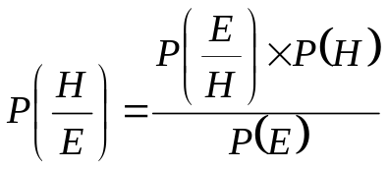 Eq4.1
- P(H) is the probability of hypothesis H being true. This is known as the prior probability.
- P(E) is the probability of the evidence(regardless of the hypothesis).
- P(E/H) is the probability of the evidence given that hypothesis is true.
- P(H/E) is the probability of the hypothesis given that the evidence is there.
Presence or absence of a feature does not influence the presence or absence of any other feature.
TYPES OF NAÏVE BAYES CLASSIFIER:
- GAUSSIAN NAÏVE BAYES
When attribute values are continuous, an assumption is made that the values associated with each class are distributed according to Gaussian i.e., Normal Distribution.

MULTINOMIAL NAIVE BAYES
Multinomial Naive Bayes is preferred to use on data that is multinomial distributed. It is one of the standard classic algorithms which is used in text categorization (classification). Each event in text classification represents the occurrence of a word in a document.

BERNOULLI NAIVE BAYES
Bernoulli Naive Bayes is used on the data that is distributed according to multivariate Bernoulli distributions. i.e., multiple features can be there, but each one is assumed to be a binary-valued (Bernoulli, Boolean) variable.

Advantages
- Naive Bayes Algorithm is a fast, highly scalable algorithm.
- Naive Bayes can be use for Binary and Multiclass classification. It provides different types of Naive Bayes Algorithms like GaussianNB, MultinomialNB, BernoulliNB.
- It is a simple algorithm that depends on doing a bunch of counts.
- Great choice for Text Classification problems. It’s a popular choice for spam email classification.
- It can be easily train on small dataset

Disadvantages
- It considers all the features to be unrelated, so it cannot learn the relationship between features.

4.2.2 SVM CLASSIFIER:
Svm classifier treated as one of the dominant classification algorithms. It is a supervised learning technique. When a dataset with features and class labels are given then Support Vector Machine can be used [13]. For a dataset consisting of features set and labels set, an SVM classifier builds a model to predict classes for new examples.
If an object is placed above the plane it is represented by equation 4.2:
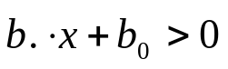 Eq 4.2
If an object is placed below the plane it is represented by equation 4.3:
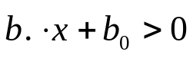 Eq 4.3

TWO KINDS OF SVM CLASSIFIERS:
- LINEAR SUPPORT VECTOR MACHINE CLASSIFIER
In Linear Classifier, A data point considered as a p-dimensional vector(list of p-numbers) and (p-1) dimensional hyperplane can be used for separation. There can be many hyperplanes separating data in a linear order, but the best hyperplane is considered to be the one which maximizes the margin i.e., the distance between hyperplane and closest data point of either class.
The Maximum-margin hyperplane is determined by the data points that lie nearest to it.. These data points which influence the hyperplane are known as support vectors.
- NON-LINEAR SUPPORT VECTOR MACHINE CLASSIFIER
Vapnik proposed Non-Linear Classifiers in 1992. It often happens that data points are not linearly separable in a p-dimensional (finite) space. To solve the above problem, it was proposed to map p-dimensional space into a much higher dimensional space.

Advantages of SVM Classifier:
- SVMs are effective when the number of features is quite large.
- It works effectively even if the number of features are greater than the number of samples.
- Non-Linear data can also be classified using customized hyperplanes built by using kernel trick.
- It is a robust model to solve prediction problems since it maximizes margin.

Disadvantages of SVM Classifier:
- The biggest limitation of Support Vector Machine is the choice of the kernel. The wrong choice of the kernel can lead to an increase in error percentage.
- SVMs have good generalization performance but they can be extremely slow in the test phase.
- SVMs have high algorithmic complexity and extensive memory requirements due to the use of quadratic programming.

4.2.3 LIBLINEAR
LIBLINEAR is a linear classifier with millions of instances and features. LIBLINEAR supports two popular binary linear classifiers: LR and linear SVM .Main features of LIBLINEAR includes Multi-class classification, Cross validation for model evaluation, Automatic parameter selection, Probability estimates (logistic regression only), Weights for unbalanced data. There are some large data for which with/without nonlinear mappings gives similar performances. Without using kernels, one can quickly train a much larger set via a linear classifier. Document classification is one such application. LIBLINEAR can run on almost every platform [21].
4.2.4 ENSEMBLE CLASSIFIER:
Ensemble methods are meta-algorithms that combine several machine learning
techniques into one predictive model in order to decrease variance (bagging),bias (boosting), or improve predictions (stacking).
Ensemble methods can be divided into two groups:
- SEQUENTIAL ENSEMBLE METHODS : The base learners are generated sequentially (e.g. AdaBoost).The basic motivation of sequential methods is to exploit the dependence between the base learners. The overall performance can be boosted by weighing previously mislabeled examples with higher weight.
- PARALLEL ENSEMBLE METHODS: The base learners are generated in parallel (e.g. Random Forest). The basic motivation of parallel methods is to exploit independence between the base learners since the error can be reduced dramatically by averaging.
4.2.4.1 STACKING:
Stacking is an ensemble learning technique that combines multiple classification or regression models via a meta-classifier or a meta-regressor. The base level models are trained based on a complete training set, then the meta-model is trained on the outputs of the base level model as features. The base level often consists of different learning algorithms and therefore stacking ensembles are often heterogeneous.

The stacking ensemble consists of k-NN, Random Forest, and Naive Bayes base classifiers whose predictions are combined by Logistic Regression as a meta-classifier. The blending of decision boundaries can be achieved by the stacking classifier. Stacking achieves higher accuracy than individual classifiers and based on learning curves, it shows no signs of over fitting. Figure 4.4 represents the ensemble stacking classifier

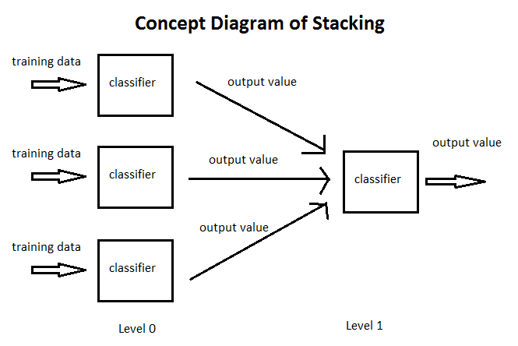
Fig 4.4 stacking ensemble classifier

4.3 PERFORMANCE METRICS
The performance of the entire system is computed in terms of accuracy, error rate, precision, recall and f-measure.
- ACCURACY:
The classification accuracy of an individual program depends on the number of samples correctly classified (true positives plus true negatives) [17] and is evaluated by the formula given in equation 4.4:

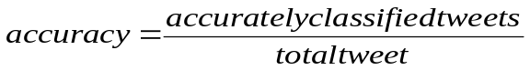 Eq 4.4

- PRECISION:
It is ratio of the total number of retrieved documents that are actually relevant [20].Precision can be calculated using equation 4.5
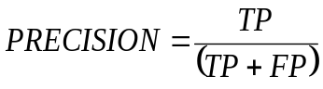 Eq 4.5
TP: true positive, FP: false positive

- ERROR RATE:
It is percent of misclassified data out of the total validation data. That can also be computed using the following formula [11]. Error rate can be calculated using equation 4.6
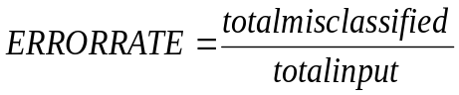 Eq 4.6

- RECALL:
Recall is the fraction of relevant instances that have been retrieved over the total amount of relevant instances [20].Recall can be calculated using equation 4.7
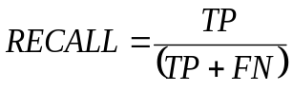 Eq 4.7

TP: true positive,
FN: false negative

- F-MEASURE:
A measure that combines precision and recall is the harmonic mean of precision and recall [11]. F-measure can be calculated using equation 4.8

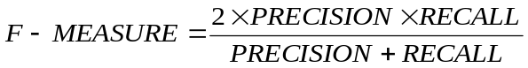 Eq 4.8

CHAPTER 5
RESULTS AND DISCUSSION

The preprocessing and experimental results have been discussed in this chapter

5.1 PRE-PROCESSING RESULT
The detailed steps of preprocessing is shown in table 5.1

TWEET | DATA CLEANING | STOP WORDS REMOVAL | STEMMING | PROCESSED TWEET
Working on some new pieces this morning. #art https://t.co/VIrw4nbE1M | Working on some new pieces this morning | Working new pieces morning | Work new piece morning | Work new piece morning
Secure Recruitment Thanks for following! Click to learn more about our #medical #device developments--&gt; https://t.co/J6bYPtmz58 | Secure Recruitment Thanks for following Click to learn more about our developments gt | Secure Recruitment Thanks following Click learn more  developments | Secure Recruitment Thank follow Click learn more  Development | Secure Recruitment Thank follow Click learn more  Development
\u201cI need to eat, clean up, eat, pack, and eat.\u201d\nCRYSTAL DECEPTION\nNew Scifi in Space,https://t.co/iYbktCPxKm\n#kindle\u2026,https://t.co/8kdLwF7CrL | U c I need to eat clean up pack and eat. U d n CRYSTAL DECEPTION n New Scifi in Space | eat, clean up pack eat. CRYSTAL DECEPTION New Scifi Space | eat, clean up pack eat. CRYSTAL DECEPTION New Scifi Space | eat, clean up pack eat. CRYSTAL DECEPTION New Scifi Space
Ugly and shameful role model! https://t.co/pxXDlOLHqX | Ugly and shameful role model | Ugly shameful role model | Ugly shame role model | Ugly shame role model
Table 5.1(preprocessing results)

5.2 CLASSIFICATION RESULTS

5.2.1 NAÏVE BAYES
Naive Bayes classifier assumes that all the features are unrelated to each other. It predicts probabilities that given tweet belongs to a particular class. The class with the highest probability is considered as the most likely class. Table 5.2 shows the performance of the classifier against various performance metrics.

Data range / performance metric | 200 | 400 | 700 | 1000
Accuracy | 0.428 | 0.39 | 0.4 | 0.42
Precision | 0.49 | 0.47 | 0.468 | 0.468
error rate | 0.58 | 0.61 | 0.6 | 0.58
Recall | 0.404 | 0.39 | 0.413 | 0.413
f-measure | 0.408 | 0.4 | 0.414 | 0.416

Table 5.2(performance analysis of naïve bayes algorithm)

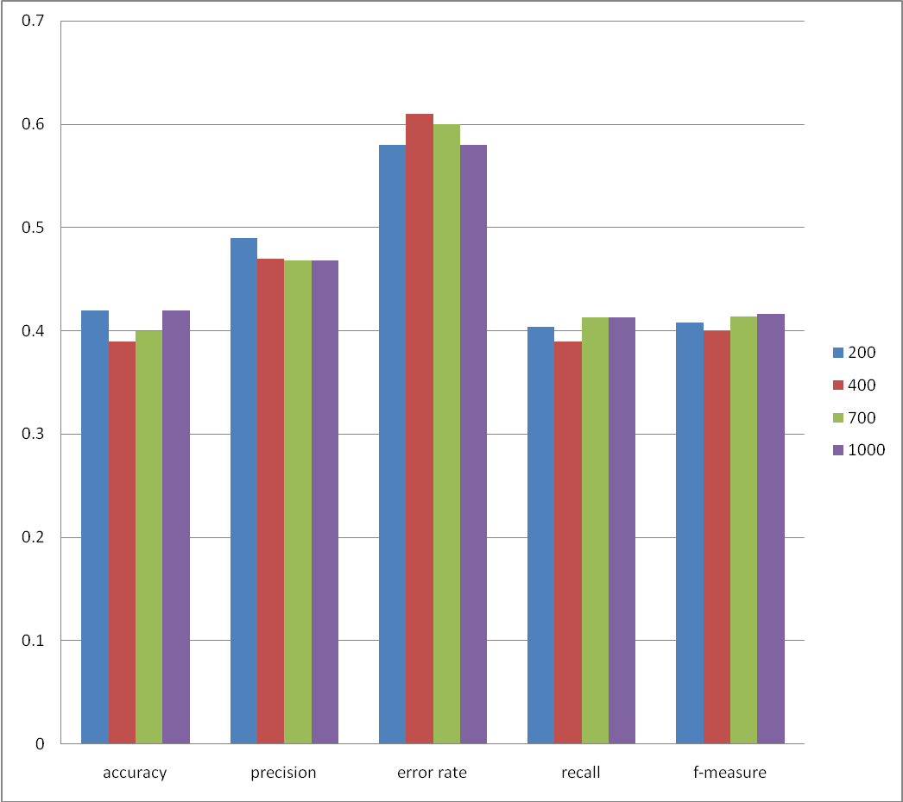

fig 5.1(performance analysis of naïve bayes algorithm)

In this classifier accuracy is maximum and when 200 testing data is. Fig 5.1 shows classification of tweets of varied range of data sets using naïve bayes classifier

5.2.2 SVM
SVM works by mapping tweets to a high-dimensional feature space so that data points can be categorized, even when the data are not linearly separable. A separator between the categories is found, then the data are transformed in such a way that the separator could be drawn as a hyperplane.thus data on sides of hyperplane is considered as class. Table 5.3 shows the performance of the classifier against various performance metrics.

Data range/performance metrics | 200 | 400 | 700 | 1000
Accuracy | 0.46 | 0.44 | 0.46 | 0.47
Precision | 0.65 | 0.66 | 0.624 | 0.6018
error rate | 0.54 | 0.56 | 0.54 | 0.53
Recall | 0.45 | 0.42 | 0.437 | 0.427
f-measure | 0.49 | 0.46 | 0.475 | 0.465

Table 5.3(performance analysis of SVM algorithm)

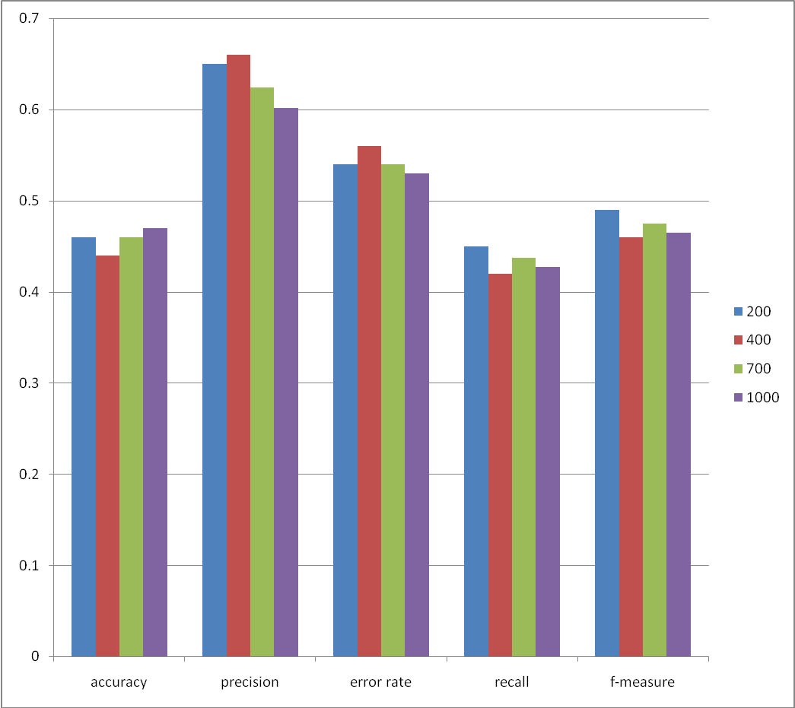

fig 5.2(performance analysis of SVM algorithm)

Fig 5.2 shows classification of tweets of varied range of data sets using SVM classifier. When 700 testing data is used accuracy is maximum

5.2.3 LIBLINEAR CLASSIFIER

Liblinear is targeted to primarily work with linear kernel .it uses one vs. rest strategy. The one-vs.-reststrategy involves training a single classifier per class, with the samples of that class as positive samples and all other samples as negatives. This strategy requires the base classifiers to produce a real-valued confidence score for its decision, rather than just a class label. It predicts class label using highest confidence score. Table 5.4 shows the performance of the classifier against various performance metrics.

Data range/performance metrics | 200 | 400 | 700 | 1000
Accuracy | 0.59 | 0.583 | 0.6 | 0.61
Precision | 0.67 | 0.666 | 0.64 | 0.64
error rate | 0.41 | 0.417 | 0.4 | 0.309
Recall | 0.55 | 0.572 | 0.58 | 0.59
f-measure | 0.56 | 0.587 | 0.59 | 0.6

Table 5.4(performance analysis of liblinear algorithm)

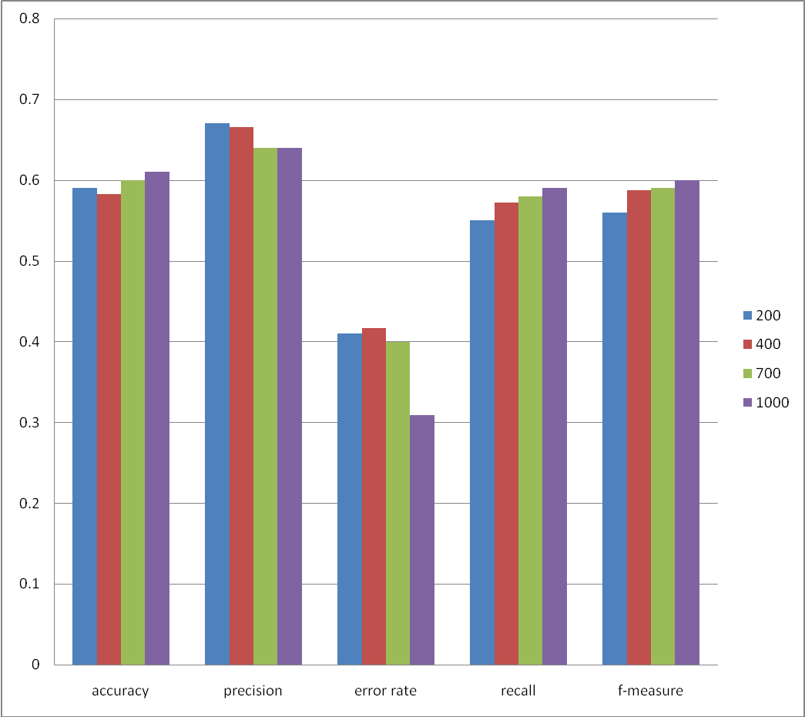

Fig5.3(classification of tweets using liblinear)

Fig 5.3shows classification of tweets of varied range of data sets using liblinear classifier. When 1000 testing data is used accuracy is maximum.

5.2.4 ENSEMBLE CLASSIFIERS(STACKING)

Ensemble classifiers give better results when compared to individual classifier.
In stacking base classifiers used in this project are naïve bayes, SVM, liblinear.
Meta classifier used is liblinear. The algorithms used in the base classifiers generate the category for the particular tweet. meta classifier combines output of the classifiers . If the meta classifier has identified any improper features, then it generates the suitable category for the tweet. Thus categories given by meta classifier is been taken as final output. Table 5.5 shows the performance of the classifier against various performance metrics.

Data range/performance metrics | 200 | 400 | 700 | 1000
Accuracy | 0.66 | 0.62 | 0.66 | 0.68
Precision | 0.434 | 0.7 | 0.698 | 0.709
error rate | 0.34 | 0.38 | 0.34 | 0.32
Recall | 0.967 | 0.62 | 0.657 | 0.669
f-measure | 0.6 | 0.63 | 0.659 | 0.672

Table 5.5(performance analysis of Ensemble classifier(stacking) )

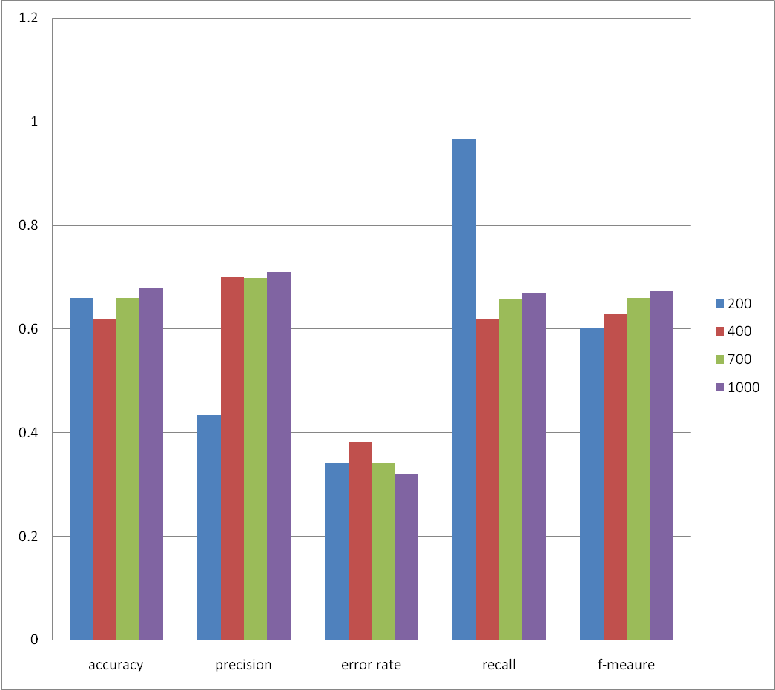

Fig 5.4(classification of tweets using stacking)

Fig 5.4 shows classification of tweets of varied range of data sets using stacking classifier. When 1000 testing data is used accuracy is maximum.

Thus overall performance of these classifiers is evaluated by taking the average of performance metrics of different series of data sets of these classifiers. Table5.6 shows performance metrics of different classifiers.

Algorithms/performance metrics | Naïve | svm | Liblinear | Stacking
Accuracy | 0.407 | 0.457 | 0.59 | 0.655
Precision | 0.47 | 0.633 | 0.65 | 0.63
error rate | 0.59 | 0.547 | 0.41 | 0.345
Recall | 0.405 | 0.433 | 0.57 | 0.728
f-measure | 0.409 | 0.472 | 0.58 | 0.64

Table 5.6(overall performance analysis)

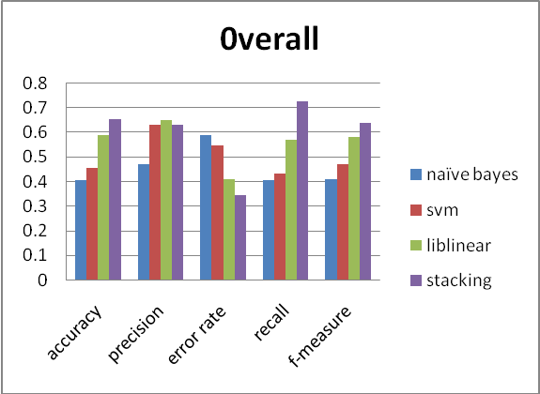
Fig 5.5( overall classification of tweets using different classifiers)

From the Fig 5.5which shows classification of tweets using different classifiers proves that ensemble classifiers shows better results when compared with other other classifiers. Stacking shows a accuracy of 65% .The stacking proves better because If a particular base-classifier incorrectly learned a certain region of the feature space, then the second tier (meta) classifier may be able to detect this undesired behavior, along with the learned behaviors of other classifiers, it can correct such improper training. Thus it gives better categorization of tweets.

CHAPTER 6
CONCLUSION AND FUTURE WORK

6.1 CONCLUSION
This project has focused on classification of real-world tweets into particular category by using existing classifiers like naïve bayes ,svm. The linear The unique characteristic of project is the
- Usage of large data sets
- Significant improvements over the performance metrics of the existing machine learning algorithms and linear classifiers .
- Usage of stacking ensemble classifier with meta classifier as liblinear model.

6.2 FUTURE WORK
Our work can be extended in several dimensions. Incorporating more training data would improve the relevance and categorization of tweets . Feature extraction can be done in more enhanced way and Additional variants of the ensemble classifier such as Artificial Neural Networks or Decision Trees can be explored and more detailed classification can be done .

REFERENCE
- Agarwal,A., Passonneau, R,Rambow, O., Vovsha, I. and Xie, B. (2011, June). “Sentiment analysis of twitter data”. In Proceedings of the workshop on languages in social media (pp. 30-38).
- Ajay,Deshwal and Sudhir Kumar Sharma .(2015). "Twitter sentiment analysis using various classification algorithms." Reliability, Infocom Technologies and Optimization (Trends and Future Directions)(ICRITO), 2016 5th International Conference on, pp 251-257.
- Anna, Caroline Brun, Claude Roux, Tomi Silander and Stavrianou. (2014). "NLP-based feature extraction for automated tweet classification." Interactions between Data Mining and Natural Language Processing , Vol. 145 .
- Alexander,Pak, and Patrick Paroubek. (2010)."Twitter as a corpus for sentiment analysis and opinion mining." In LREc, Vol. 10.
- Bing Liu,Bjorn Schuller,Cambria, Erik,Catherine Havasi and Haixun Wang. (2013). "Statistical approaches to concept-level sentiment analysis." IEEE Intelligent Systems , Vol. 28, pp 6-9 .
- Beenish Zahoor,Gull, Ratab,Saba Rasheed, Umar Shoaib and Washma Abid. (2016) "Pre Processing of Twitter's Data for Opinion Mining in Political Context." Procedia Computer Science ,Vol.96, pp 1560-1570.
- Chang, K.W.,Fan, R.E., Hsieh, C.J.,Lin, C.J, and Wang, X.R. (2008).” LIBLINEAR: A library for large linear classification”. Journal of machine learning research, 9(Aug), vol.9, pp.1871-1874 .
- Chengqing Zong, Rui, Shoushan Li and Xia (2011)."Ensemble of feature sets and classification algorithms for sentiment classification." Information Sciences ,Vol.181, pp 1138-1152 .

Chinmay Chandak, Manish Singh,Naveen Reddy Chedeti, Sahni and Tapan. (2017). "Efficient Twitter sentiment classification using subjective distant supervision." In Communication Systems and Networks (COMSNETS), 2017 9th International Conference, Vol. 1 pp 548-553.
- Chung,Eni Mustafaraj and Jessica Elan. (2011). " Can collective sentiment expressed on twitter predict political elections?". AAAI ,Vol. 11, pp 1770-1771.
- Cui, Gagan Agrawal, Rajiv Ramnath,Renhao and Vinh Khuc, (2016)"Ensemble of Heterogeneous Classifiers for Improving Automated Tweet Classification." Data Mining Workshops (ICDMW), 2016 IEEE 16th International Conference on, pp 1045-1052.
- Devendra Paratwar,Indrajit Gohokar,Jayant Sable, Mohit, Rakhi Wajgi and Tare. (2014). "Multi-class tweet categorization using map reduce paradigm." International Journal of Computer Trends and Technology (IJCTT), Vol. 9, p 78 .
- Dwi Aji,Kurniawan,Noor Akhmad Setiawan and Sunu Wibirama .(2016). "Real-time traffic classification with Twitter data mining." Information Technology and Electrical Engineering (ICITEE), 2016 8th International Conference on, pp. 1-5.
- Guddeti, R.M.R and Kanakaraj, M.. (2015).” NLP based sentiment analysis on Twitter data using ensemble classifiers”. In Signal processing, communication and networking (ICSCN), 2015 3rd international conference on (pp. 1-5).
- Janyce Wiebe,Theresa, Paul Hoffmann and Wilson. (2005). "Recognizing contextual polarity in phrase-level sentiment analysis." Proceedings of the conference on human language technology and empirical methods in natural language processing, Vol. 7,pp 347-354 .
- Jeonghee, Wayne Niblack and Yi. (2005). "Sentiment mining in Web Fountain." Data Engineering, 2005. ICDE 2005. Proceedings. 21st International Conference on, pp 1073-1083.
- Jin Zhang, Songbo and Tan(2008).” An empirical study of sentiment analysis for Chinese documents". Expert System with application, Vol. 4, pp 2622-2629.
- Jonathon,Read (2005) "Using emoticons to reduce dependency in machine learning techniques for sentiment classification". Proceedings of the ACL Student Research Workshop. Association for Computational linguistics, pp 43-48.
- Luo, Miles, Osborne,Ting Wang and Zhunchen. (2015) " An effective approach to tweets opinion retrieval". World Wide Web, Vol. 18, pp 545-566 .
- Makoto Okazaki,Sakaki , Takeshi and Yutaka Matsuo (2010)." Earthquake shakes Twitter users: real-time event detection by social sensors". Proceedings of the 19th international conference on World wide web, pp 851-860.
- Melville, Prem,Richard D. Lawrence and Wojciech Gryc (2009), "Sentiment analysis of blogs by combining lexical knowledge with text classification." In Proceedings of the 15th ACM SIGKDD international conference on Knowledge discovery and data mining, pp 1275-1284.

- Nair, P.S., and Shrivastava, S. (2015) “Mood prediction on tweets using classification algorithm”. Int J Sci Res (IJSR), Vol4 (11), pp.295-299.
- Qigang Gao,Wan and Yun. " (2015). An ensemble sentiment classification system of twitter data for airline services analysis." Data Mining Workshop (ICDMW), 2015 IEEE International Conference on, pp 1318-1325.

